Burning Food

The standard enthalpy of combustion (∆*Hc*) is the enthalpy change when one mole of a substance undergoes complete combustion with oxygen at standard states, under standard conditions.

Calculate the heat gained by the substance (water).

q *substance* = mcΔT

*where:*

* **q substance** is the heat gained by water in joules (J)
* **m** is the mass of water in kilograms (kg)
* **c** is the specific heat capacity of water (4.18 x 103 J kg-1K-1)
* **∆T** is the change in temperature of water in kelvin (K)

Materials

* Food
* Bunsen burner
* Trays for holding food
* Test tubes
* Thermometer
* 10mL measuring cylinder
* Retort stand and clamp
* Matches
* Tripod and gauze mat
* Tongs

Risk Assessment

|  |  |
| --- | --- |
| What are the risks in doing this experiment? | How can you manage these risks to stay safe? |
| Food is flammable and may trigger allergies. | Wear appropriate safety gear, including eye protection (goggles). |
| Using a burner will make objects very hot. | Do not touch the hot surfaces with your hands. Always use tongs. |

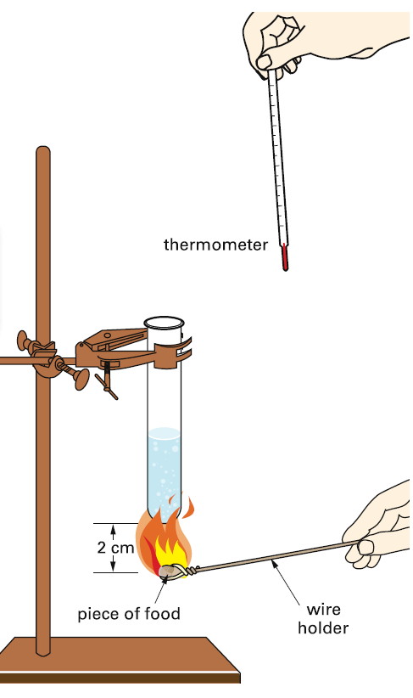

Procedure/Method

1. Set up the equipment as shown. The test tube should be clamped so that it sits just above the food tray.
2. Use a measuring cylinder to transfer 10mL of cold water to the test tube.
3. Record the initial temperature of the water using a thermometer.
4. Weigh the food as accurately as possible, and record the mass.
5. Light the bunsen burner. Put the food in the flame. As soon as it catches fire, rest it on the tripod so that it sits about 2cm under the test tube. Monitor the temperature and observe the flame.
6. When the food stops burning, stir the water gently with the thermometer and record the final temperature.
7. Repeat the experiment with three different food types.

Results

**Table 1.** Observed temperature of water and mass of food. Observed flame colour and soot deposition.

|  |  |  |  |  |  |  |
| --- | --- | --- | --- | --- | --- | --- |
|  | | **Food Type** | | | | |
|  |  |  |  |  |
| **Temperature (°C) of water in Test Tube** | Initial |  |  |  |  |  |
| Final |  |  |  |  |  |
| Temperature Change (∆°C) |  |  |  |  |  |
| **Mass / Weight (g) of Food** | |  |  |  |  |  |
| **Observation of flame colour** | |  |  |  |  |  |
| **Observation of Soot Deposition** | |  |  |  |  |  |

Discussion

1. Which food produces the most energy per gram?
2. Does all the heat produced by combustion go into raising the temperature of the water?

**Quantitative Analysis**

**Table 2.** Calculated quantity of the foods for the enthalpy of combustion.

|  |  |  |  |  |  |
| --- | --- | --- | --- | --- | --- |
| **Calculated Quantity** |  |  |  |  |  |
| **△T**: Change in temperature (°C) |  |  |  |  |  |
| **m**: mass of water heated (g) |  |  |  |  |  |
| **q substance**: quantity of heat gained by water (kJ) |  |  |  |  |  |
| **q combustion process**: quantity of heat released by the combustion process (kJ) |  |  |  |  |  |
| Mass of food burned (g) |  |  |  |  |  |
| **Experimental enthalpy of combustion (kJ g-1)** (∆*Hc)* |  |  |  |  |  |
| **Experimental enthalpy of combustion (kJ/100g)** (∆*Hc)* |  |  |  |  |  |

**Table 3.** Comparison of the theoretical value experimental of enthalpy of combustion given as percentage error.

|  |  |  |  |
| --- | --- | --- | --- |
|  | **Theoretical** enthalpy of combustion (kJ/100 g) (∆*Hc)* | **Experimental** enthalpy of combustion (kJ/100g) (∆*Hc)* | **% error** |
| Methanol |  |  |  |
| Ethanol |  |  |  |
| Propan-1-ol |  |  |  |
| Butan-1-ol |  |  |  |
| Pentan-1-ol |  |  |  |

% error = $\frac{theoretical value-experimental value}{theoretical value}×100$

Calorimetry formulas

q *substance* = mcΔT

q *combustion process* = ­­– q *substance*

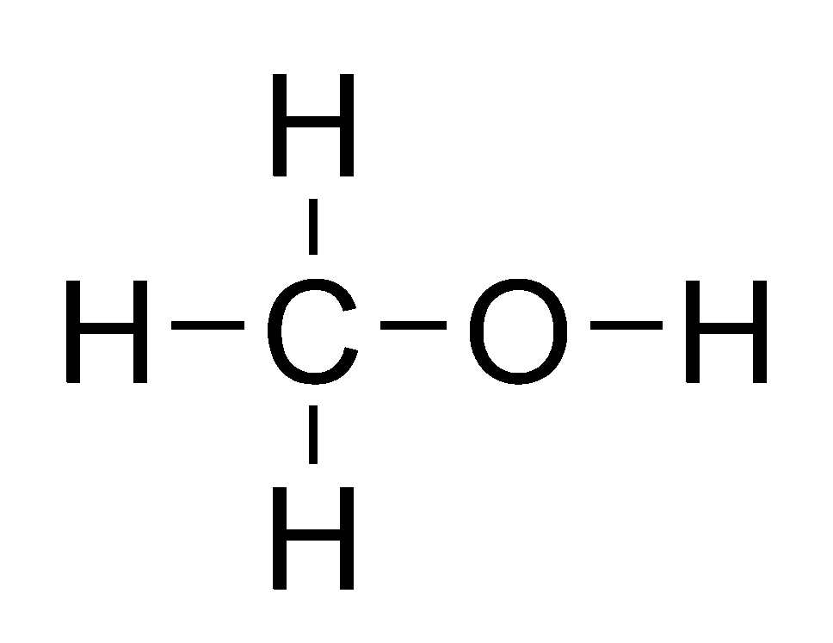

**Calorimetry calculations** – Methanol (CH3OH) Example

1. Calculate the heat gained by the water.

q *substance* = mcΔT

= 0.2 kg x (4.18 x 10-3 J kg-1 °C) x (35.0°C – 25.0°C)

= 8360 J

1. Calculate the heat released by the combustion process.

q *combustion process* = ­­– q *substance*

= ­­– 8360 J

= ­­– 8.36 kJ

1. Calculate the enthalpy change of the process.

$∆H_{c}=\frac{q_{combustion process}}{m_{combustion process}}$

= $\frac{-8.36}{0.55}$

= ­­-15.2 kJ g -1